**Assignment 1- Install Ubuntu**

**Pt1-**

**Creation of VM and installing Linux**

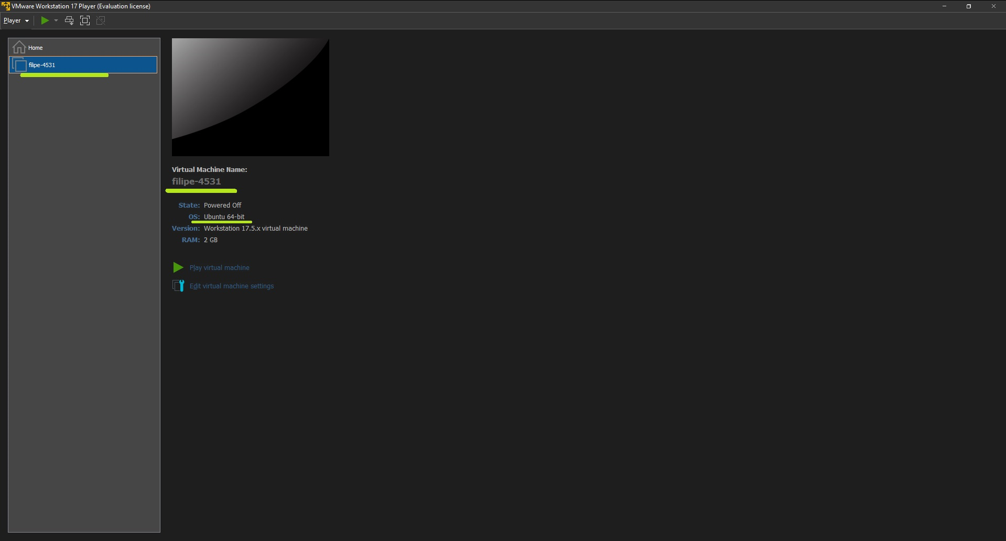

**Login - user**

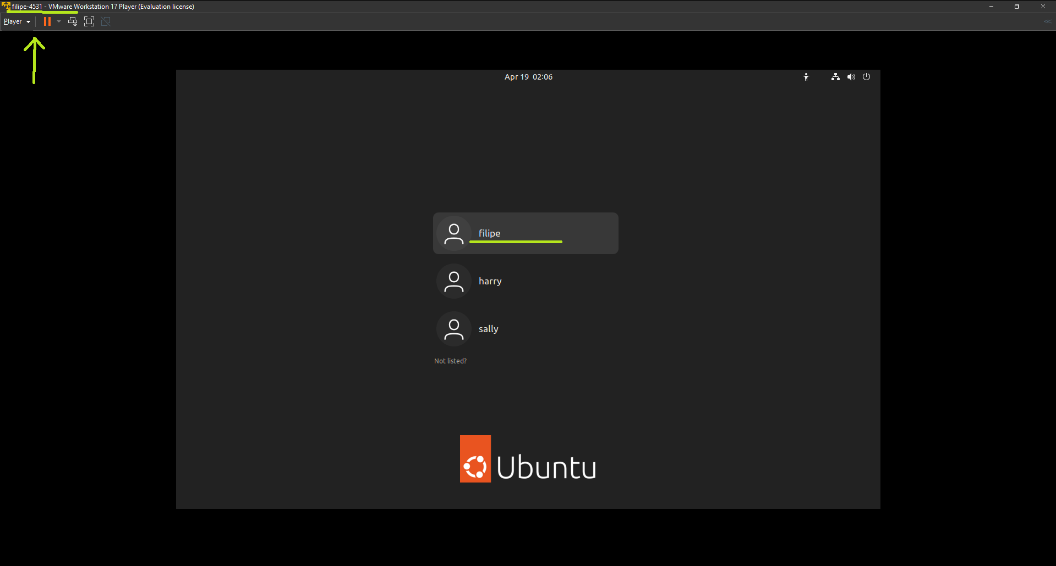

**Pt2-**

**Set username to be my first name. Set hostname to be the first 3 letters of my last name + my student ID**

**User of command on terminal:  
echo $USER  
hostname**

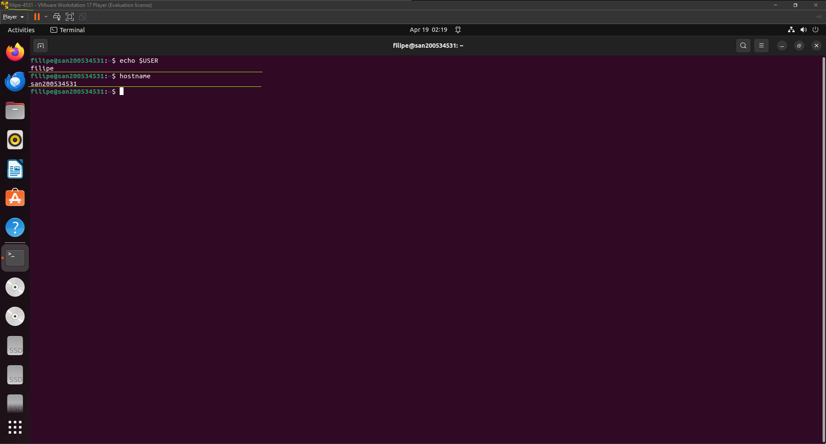

**Assignment2 - The commandline interface**

**Enabling SSH and connecting remotely to VM through Windows Console**

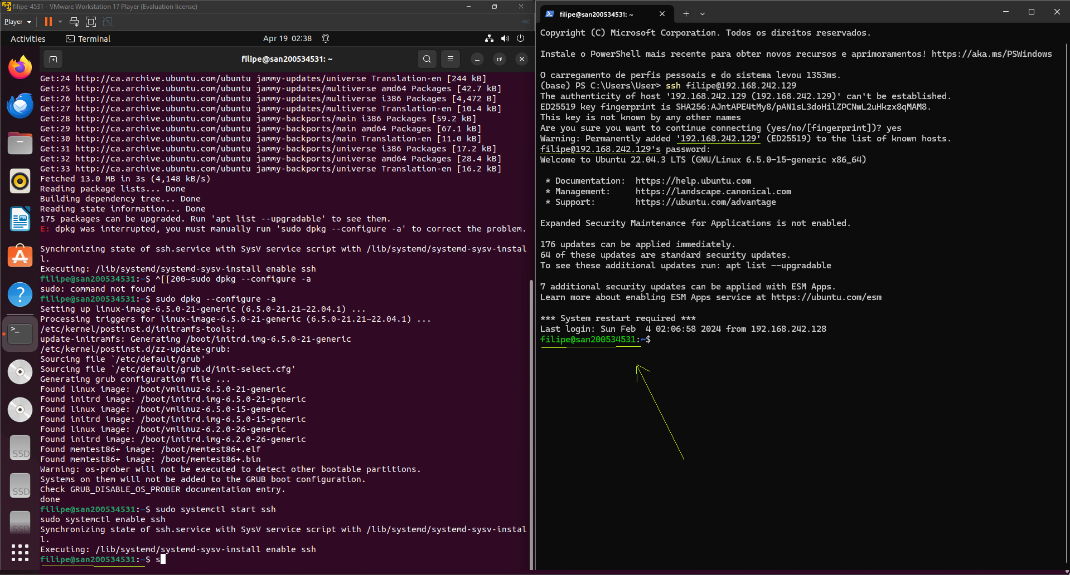

**Pt1-**

* **Create a ls command to only display filenames that start with the letter “a” and are up to 3characters long (any letters and numbers).**
* **Create a ls command to only display filenames that have only 2 letters in them (not numbers)**
* **Create a ls command to only display filenames that are 3-digit numbers (no letters)**

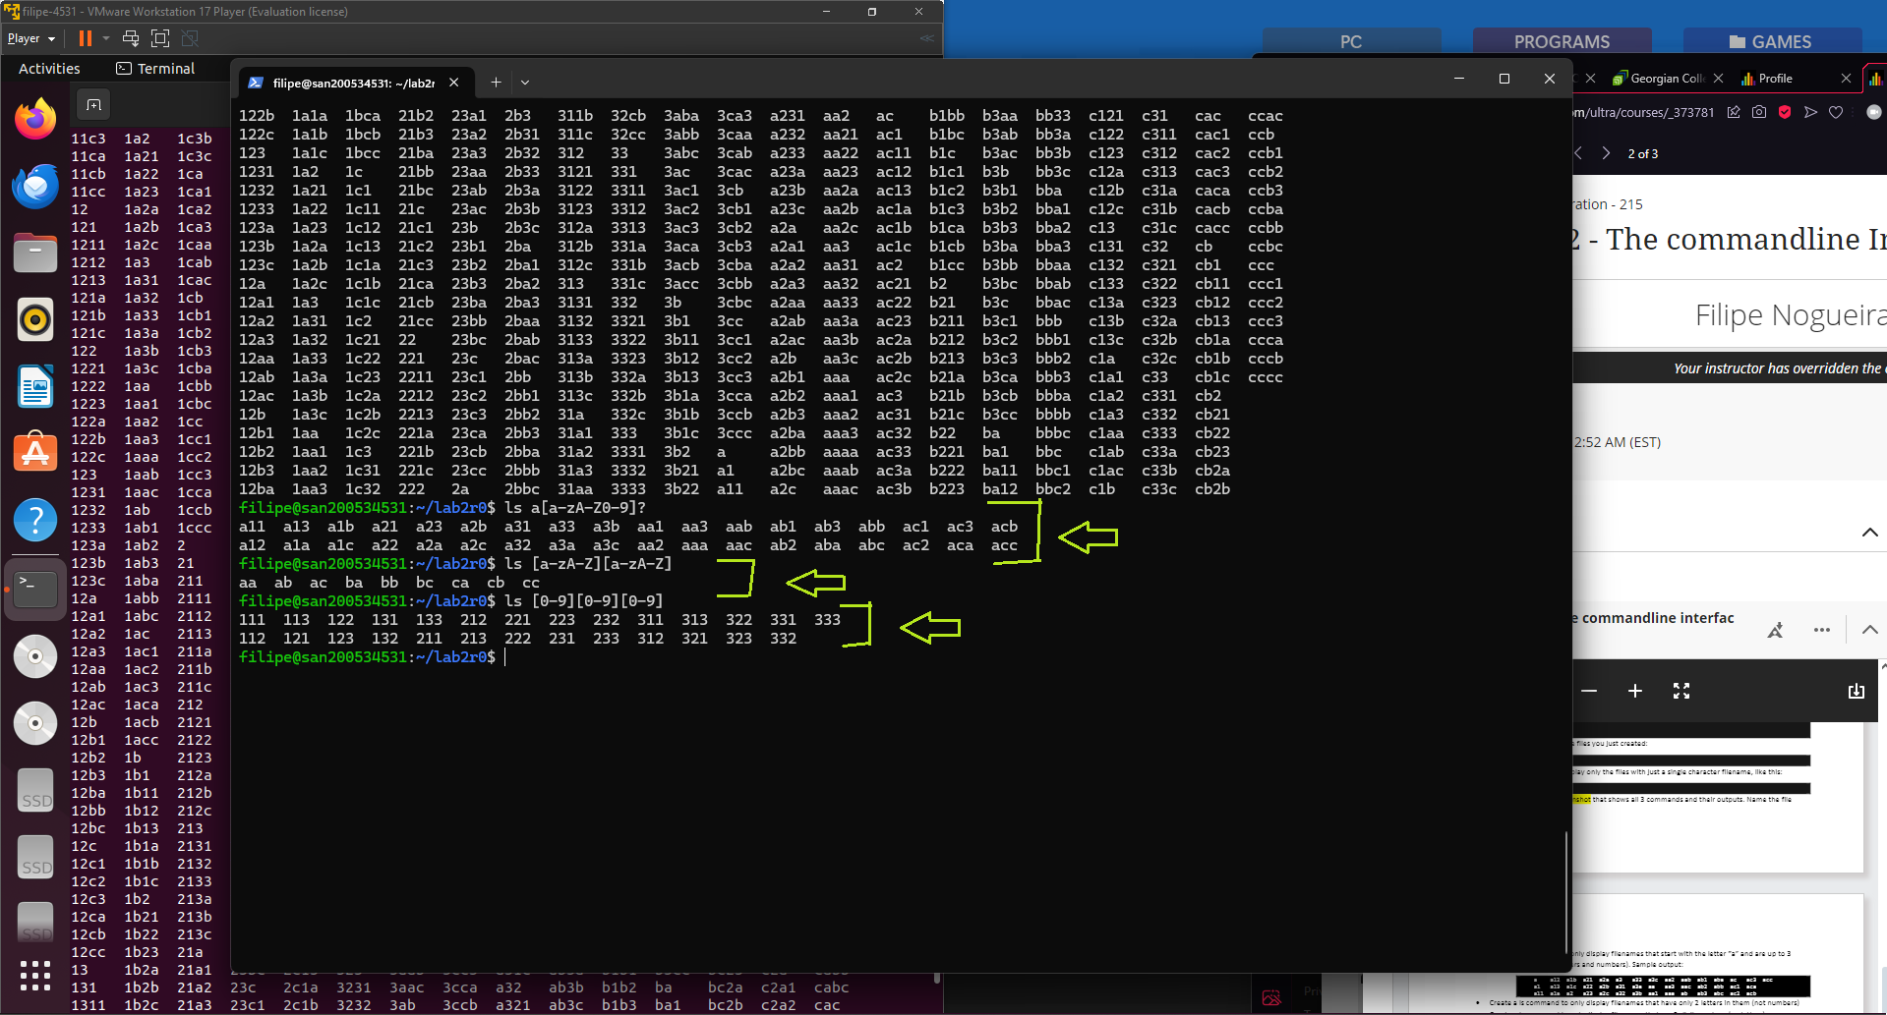

**Screenshot 1**

**Pt2- File and Folder management**

**(5 questions)**

**1- Create a directory under your lab2 directory called "dir_abc".**

**mkdir ~/lab2/dir_abc**

**2- Move all the files starting with letters a, b, or c into the "dir_abc" folder using mv command.**

**mv ~/lab2/[a-c]* ~/lab2/dir_abc/**

**3- Copy all the files starting with any number to a new folder called "numbers".**

**Altough not mentioned, we first need to create another folder, as the step before, so**

**mkdir ~/lab2/numbers**

**and then we can use the following command**

**cp ~/lab2/[0-9]* ~/lab2/numbers/**

**4- Remove all the files under the lab2 folder that start with "12" using rm command.**

**rm ~/lab2/12\***

**5- Remove the "numbers" directory.**

**rm -r ~/lab2/numbers**

**Pt3 - Escaping special characters**

**Create an echo command to show the following output exactly as it is shown**

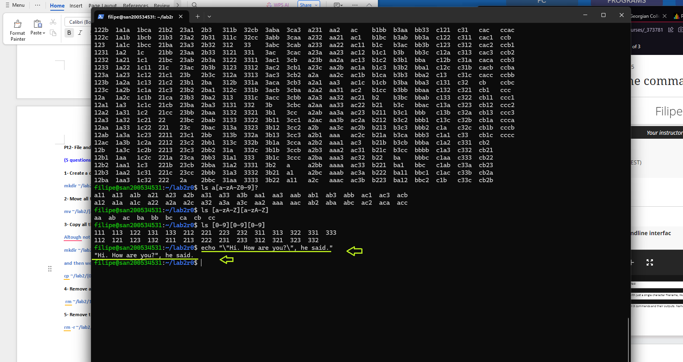

**Screenshot 2**

**Command history**  
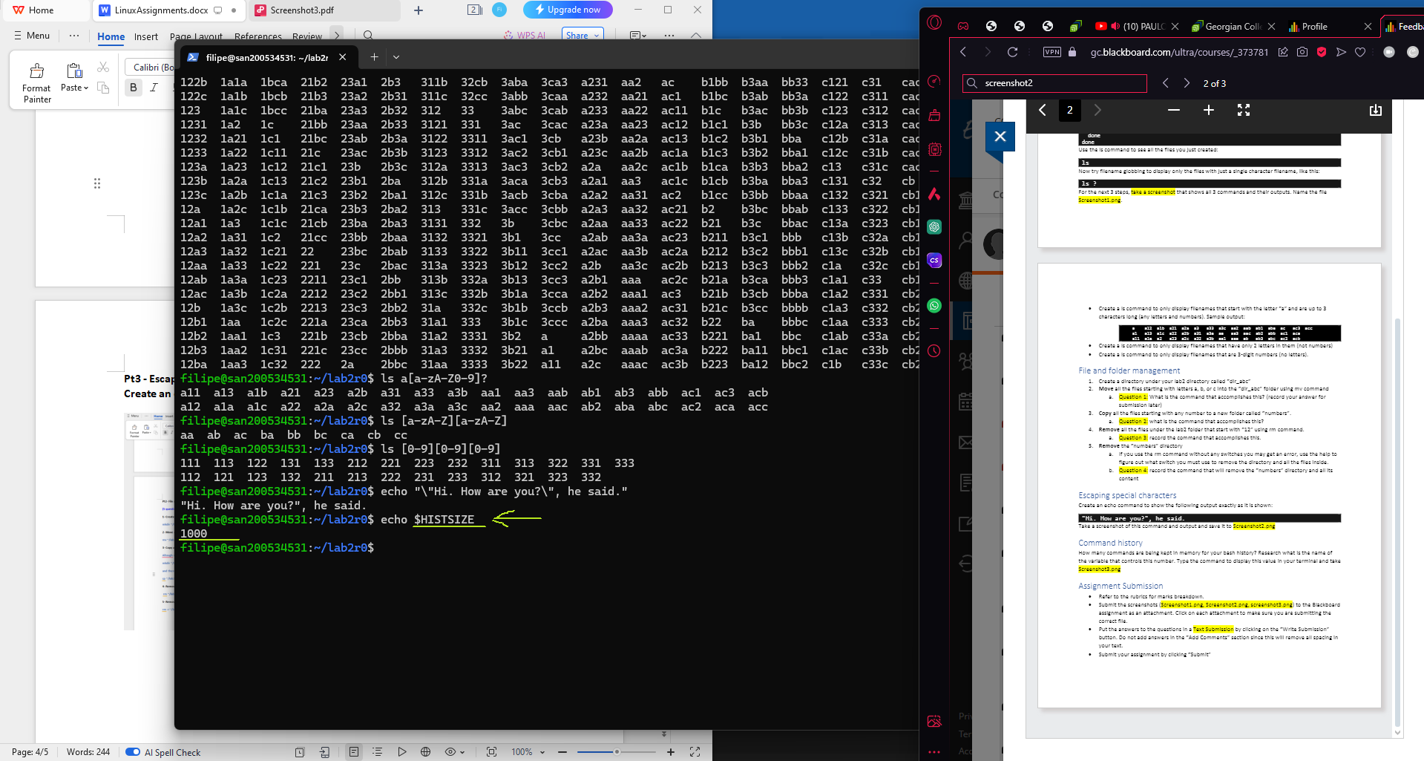

**Screenshot 3**

**Assignment3 - Configuring NIC**

**Change IP DHCP, last 4 digits of ID (4531)**

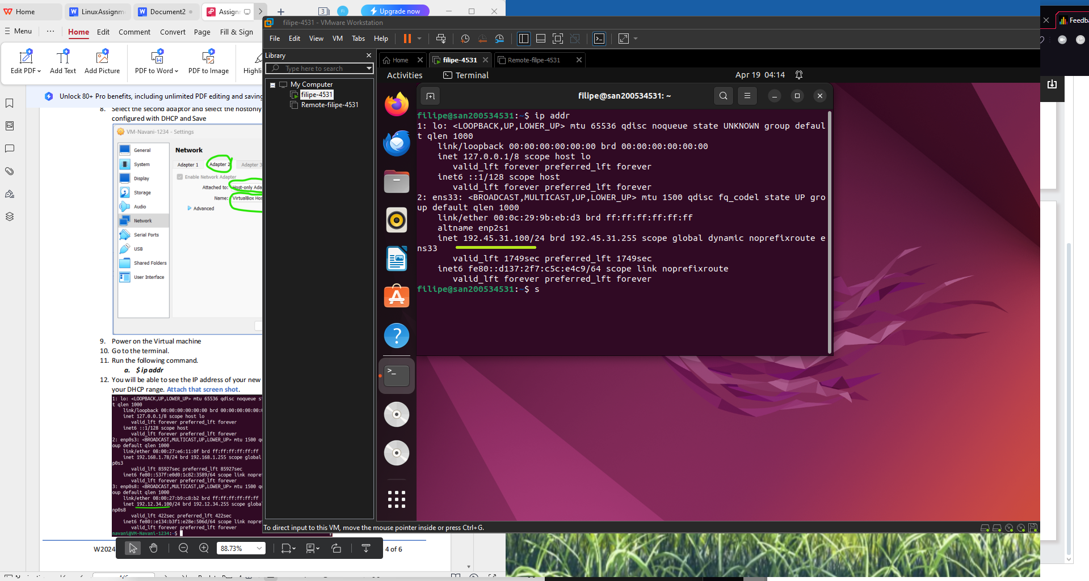

**Screenshot1**

**Change the IP address to static address using Network Manager tool nmcli with the last**

**octet of the IP address as 250**

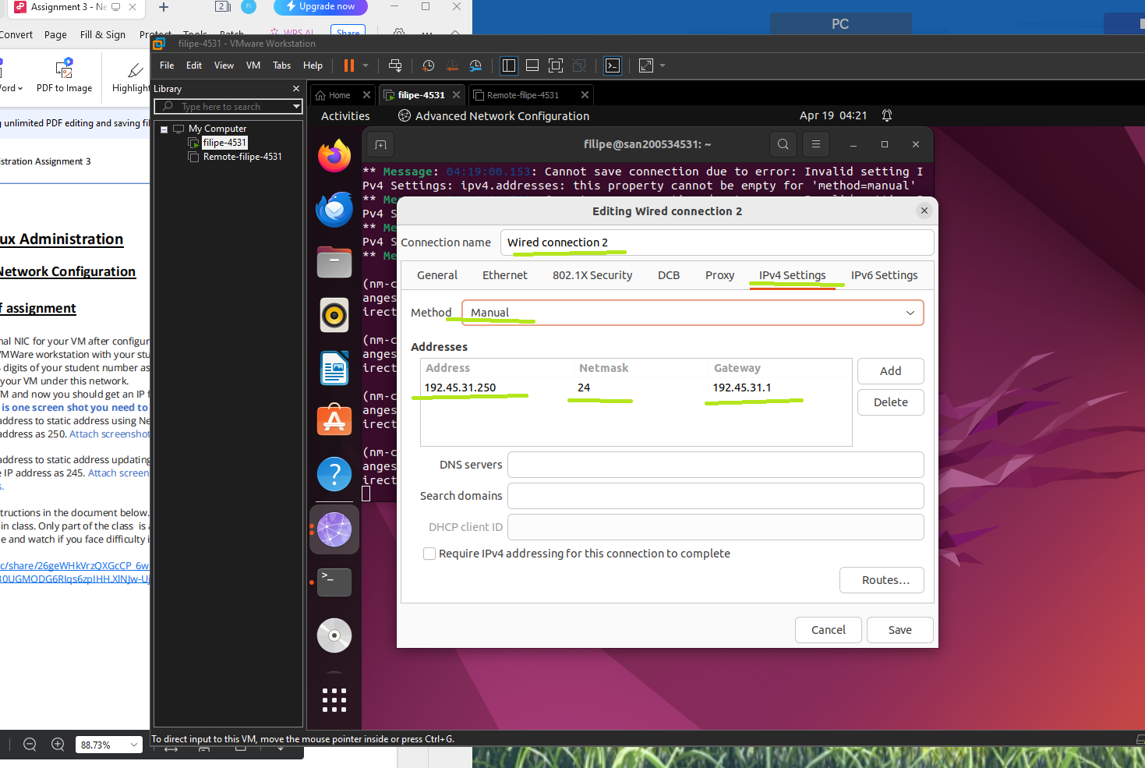

**Screenshot 2**

**Change the IP address to static address updating the yaml file in using netplan with the**

**last octet of the IP address as 250**

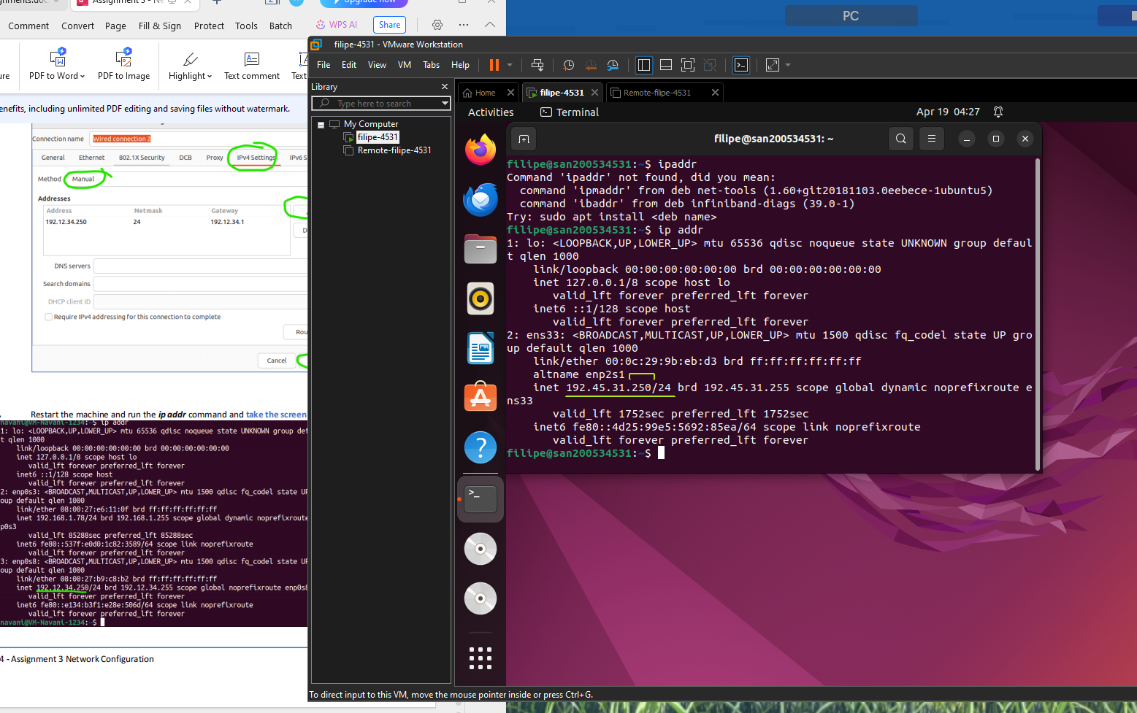

**Screenshot 3**

**Assignment8 - Linux Scripting and Changing Desktop Environment**

**Part 1- Write Script in Linux**

**Script 1**

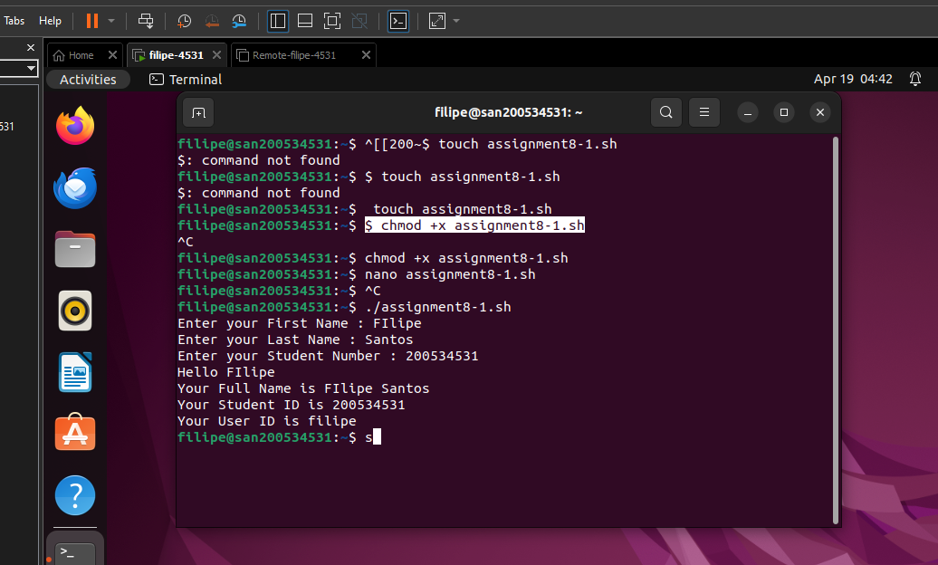

**Script 2**

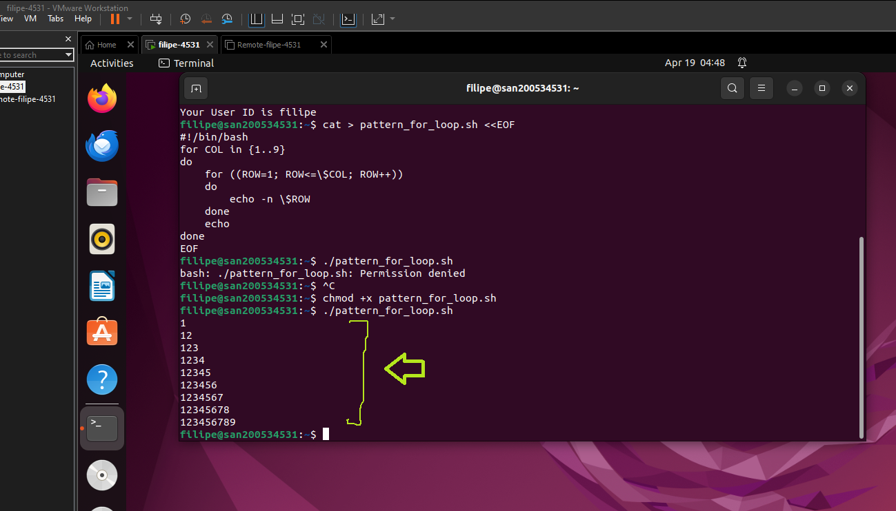

**Script 3 (Same output as script 2 but using While loop)**

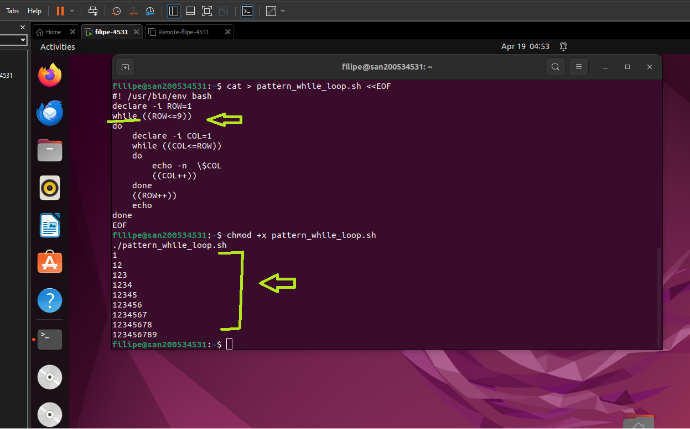

**Script 4 Using until**

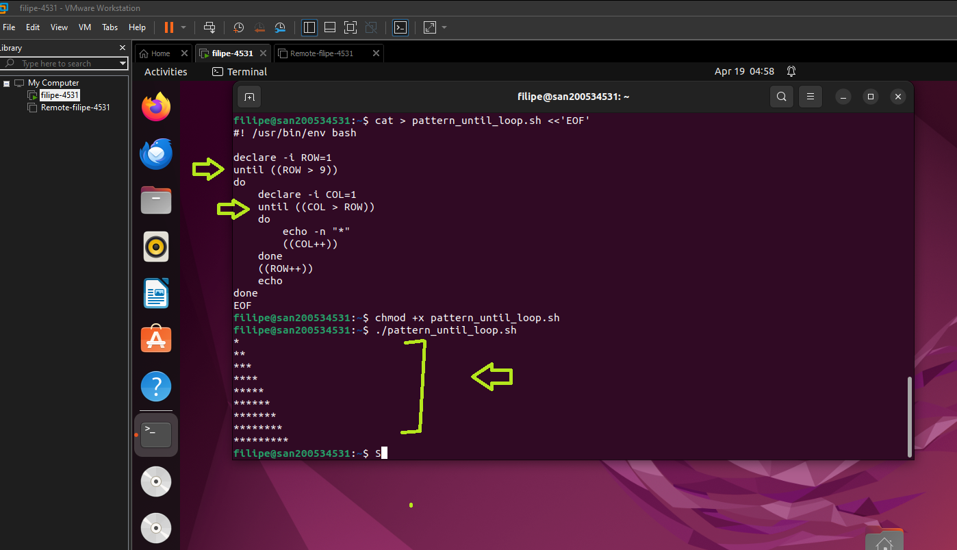

**Part 2 - Install a different desktop environment**

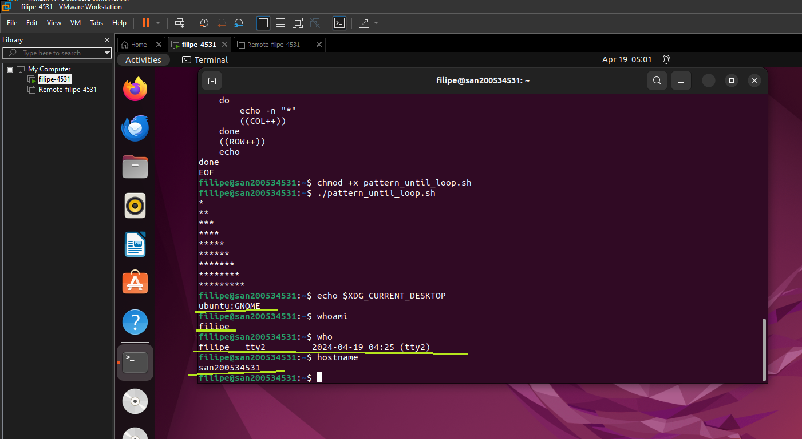

**Screenshot 1**

**Cinnamon Desktop Environment Installed**

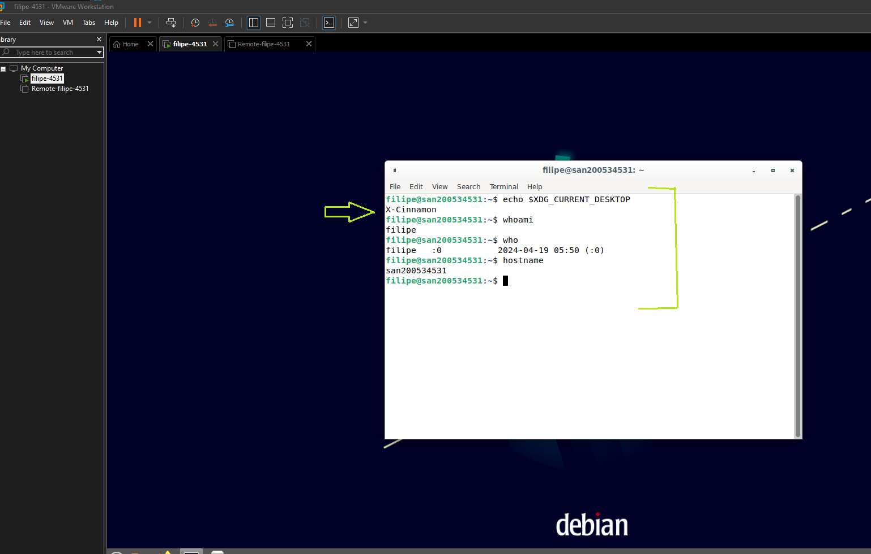

**Screenshot 2**